SMA

Experiment 1

Name:

Roll No:

Div:

CASE STUDY: Apple

1. List each company and their social media accounts.

Twitter  
<https://twitter.com/Apple>

Youtube:  
<https://www.youtube.com/@Apple>

Instagram:

<https://www.instagram.com/apple>

Facebook  
<https://www.facebook.com/apple>

2. Find as many counts for each social media account as described in the section on measuring success.

Twitter:  
8.9M followers

Instagram:

29.2 M

Youtube:  
16.8M Subs

3. How often does the company interact on their social network site? Is it many times a day, a few times a week, or never?

Twitter:

Few times a month.

Instagram:

Thrice a week.

YouTube:

Twice Per Week.

4. What kind of interaction is the company doing? Broadcast, request for input, direct interaction, or a combination? Provide an example of each.

1. Advertising and marketing through Instagram reels and memes.

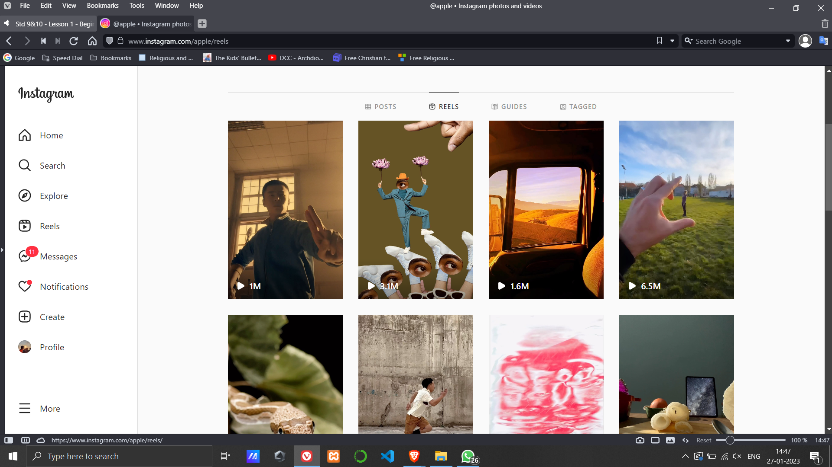

1. Sharing their achievements on the page

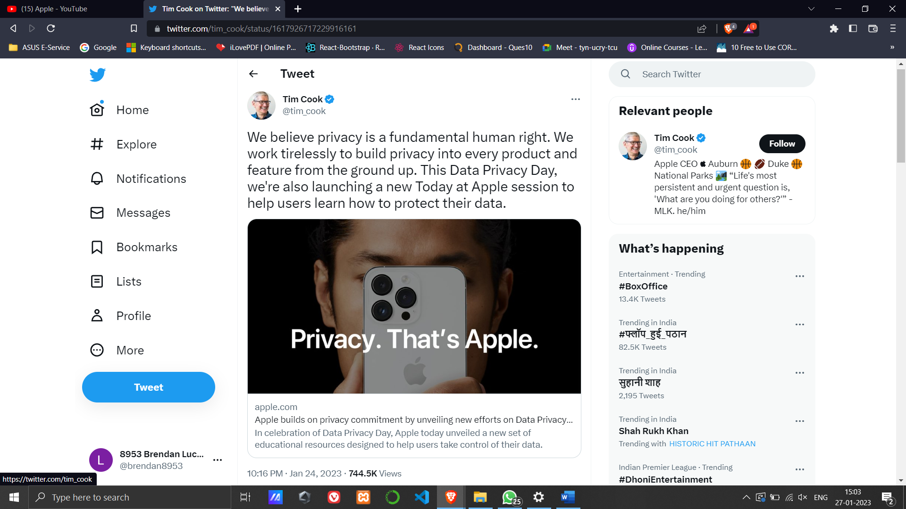

1. Request for input: asking followers to answer various questions through tweets to achieve user engagement

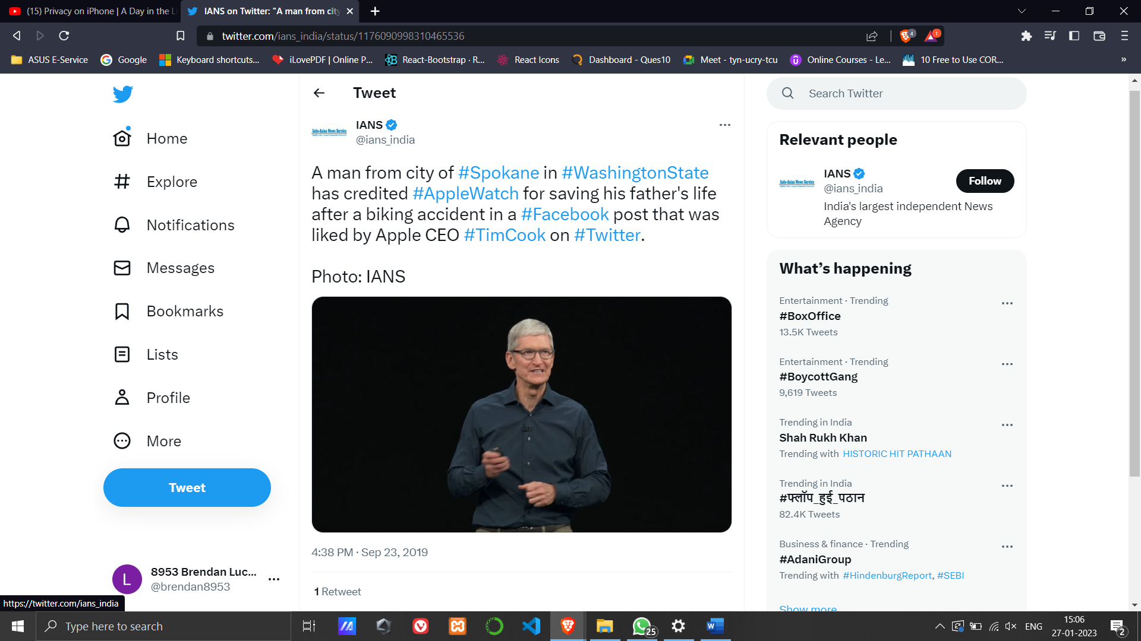

1. Broadcasting of various informative and strategic videos on youtube.  
   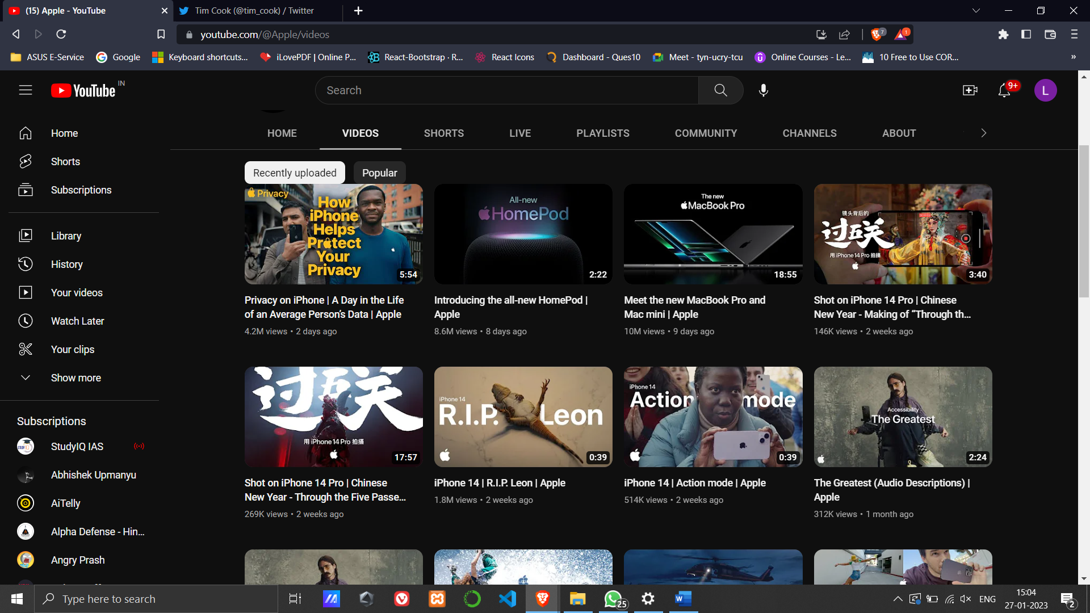
2. Assess the company’s social media strategy. What are they doing well and why? What could they do better, why would that be better, and how should they do it?

Instagram:

Shopify has used a viral content format to reinforce engagement. It uses memes and viral videos to add humor to Instagram posts. They experiment with different content formats such as using popular meme templates, trending audios, quizzes, behind-the-scenes, etc. This is a good strategy for engaging customers with Instagram posts and humanizing brand.

Twitter:

Shopify uses twitter polls to ask questions and get feedback on new products, features, branding, or content. This information can be used to improve products.

Facebook:

Video has been a significant part of Shopify’s Facebook marketing strategy because the brand is aware that video content contributes to the development of strong brand recall.

Youtube:

Shopify has created different YouTube channels, such as Learn with Shopify, Help Center, Shopify plus, Devs, etc.Having multiple YouTube channels makes it easier for people searching for content to find it. And with a clear focus on each channel, it is likely to attract new viewers in the long run.

ii) Social Media analytics tools (facebook insights, google analytics netlytic etc)

iv) Applications of Social media analytics for business.

Netlytic analysis for shopify

<https://netlytic.org>

For twitter dataset  
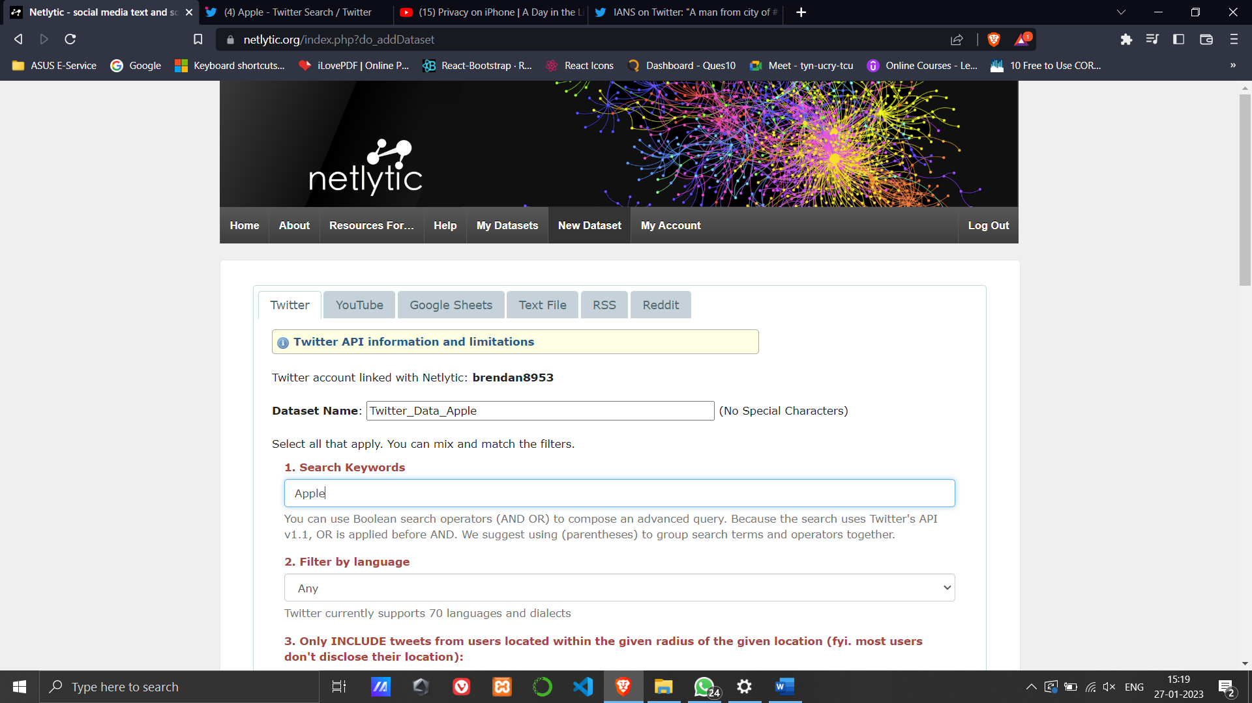

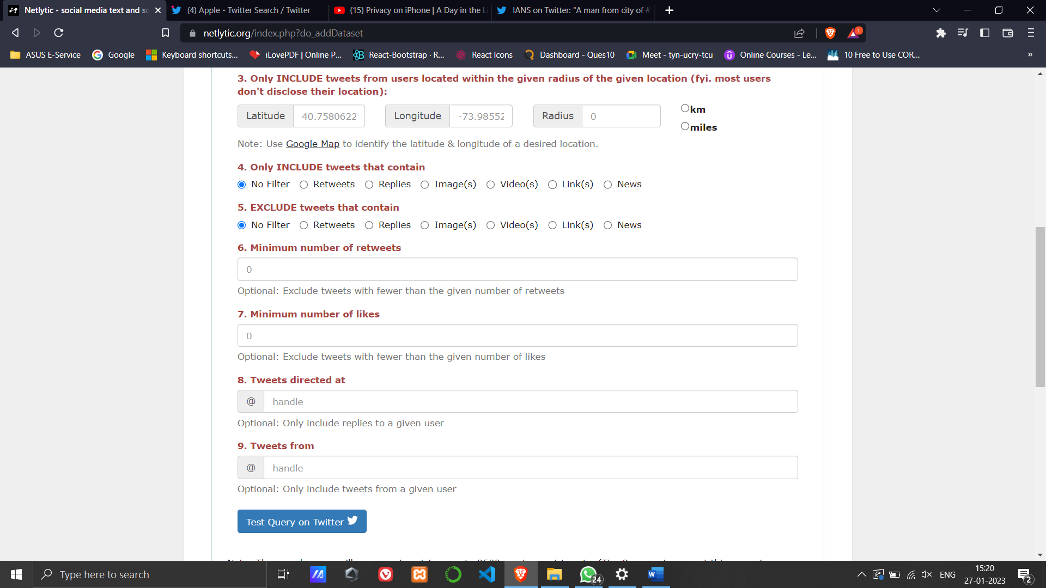

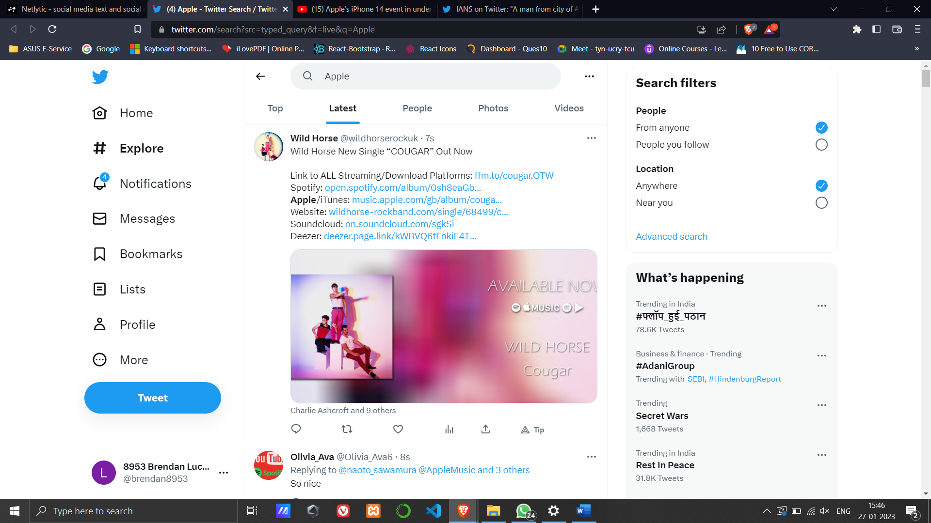

For youtube dataset  
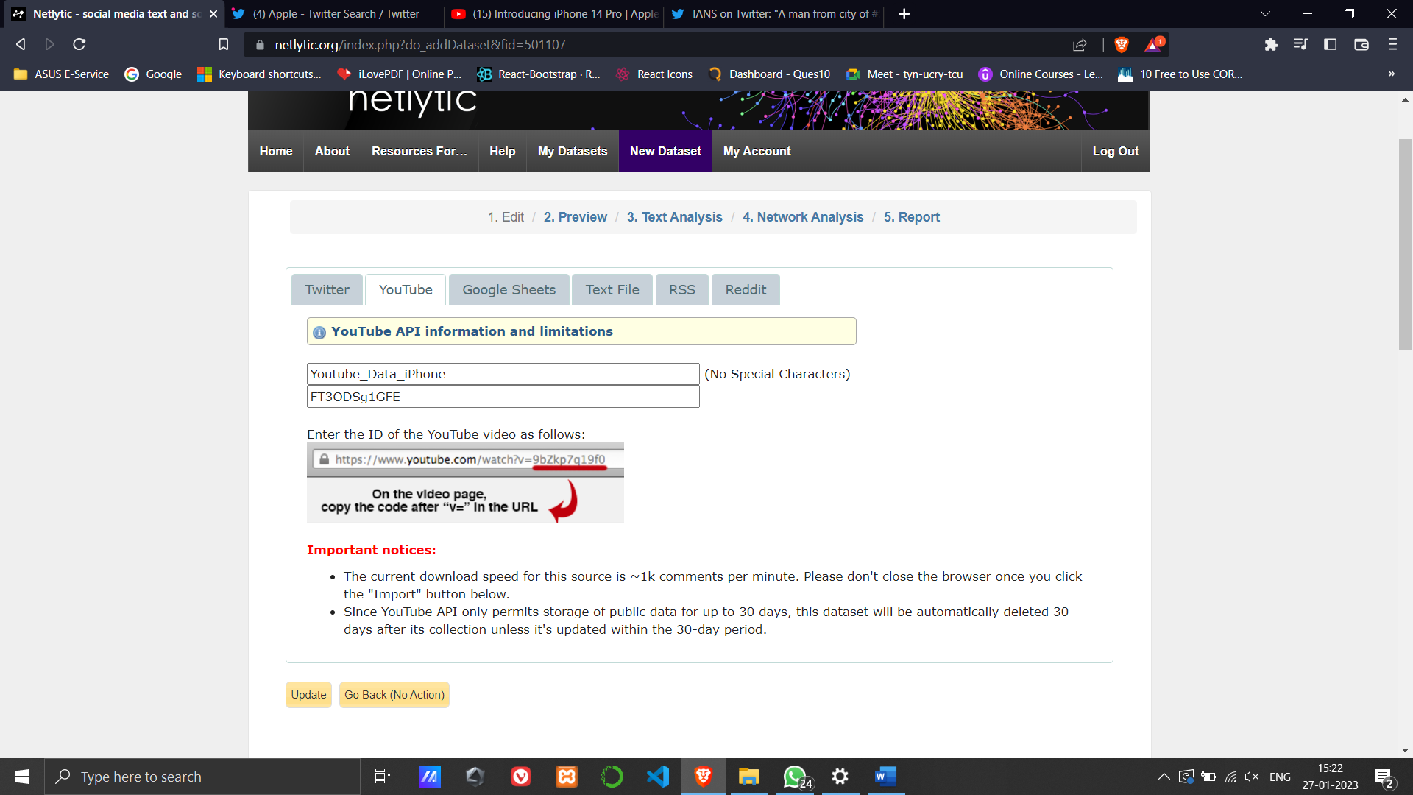

Text Analysis on Youtube Dataset for Apple:

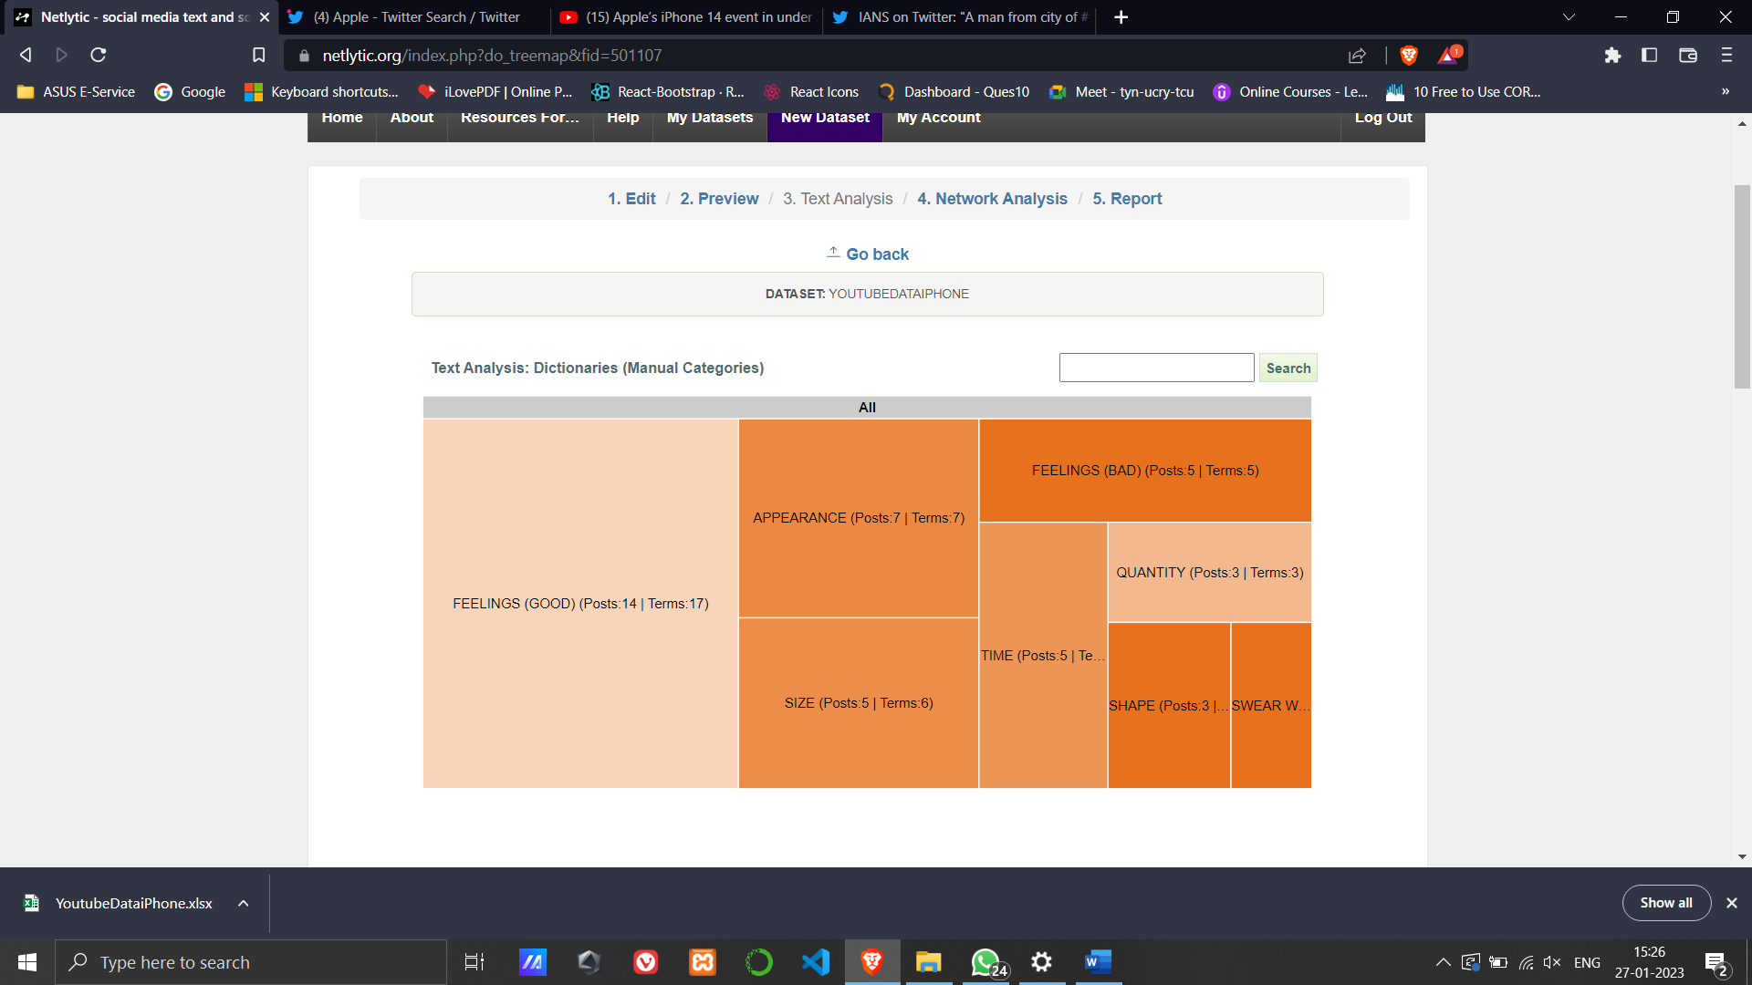

Network Analysis on Twitter Dataset for Apple:

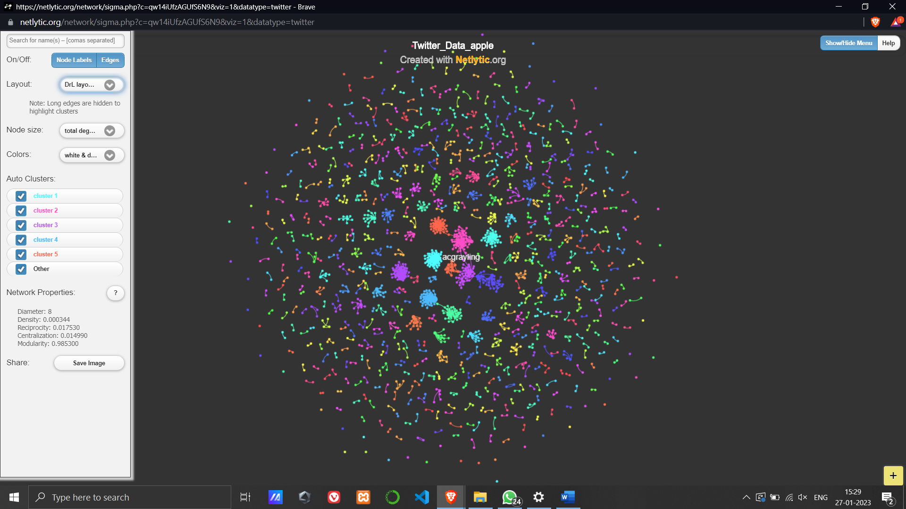

Network Analysis on Youtube Dataset for Apple:

